Alg II Name

Name _______________________   
   
 Pd__

Final Exam Review

**Complete to Replace Lowest Test Grade with Your Final Exam Grade**

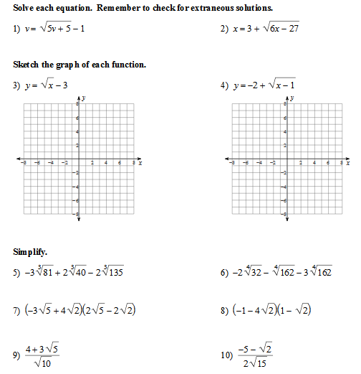

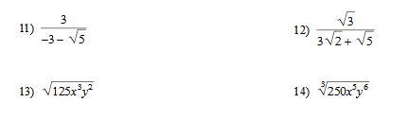

15. Graph the following functions A. B. C. D.

16. Solve the following rational inequalities

A. B. C.

17. Create a the box-and-whisker plot of the following data: 3, 5, 7, 2, 5, 3, 8, 7, 3, 4, 5, 2, 4, 5, 3, 7

18. Use the data set below to answer A, B, and C.

Number of hours students spend studying each night: 1, 0, 3, 2, 5, 2, 4, 3, 1, 0, 7, 8, 3, 5, 2, 1

A. What is the mean and standard deviation?

B. Plot the mean and standard deviation on a normal curve (bell curve).

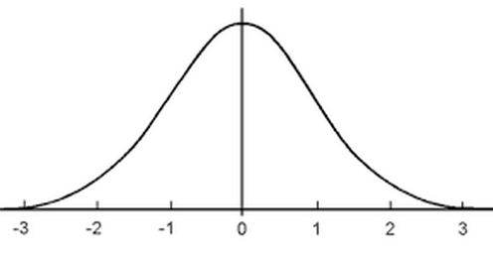

C. 68% of the data falls between ___ standard deviations and is ______ to _______

95% of the data falls between ___ standard deviations and is ______ to _______

99.7% of the data falls between ___ standard deviations and is _____to ________

19. Solve:

20. Graph:

21. Solve:

22. Graph:

23. Solve the system: $-2y^{2}-3x-13y-3=0$ $-2x^{2}-x+y-5=0$

$x+3y+1=0$ $x-y= -1$

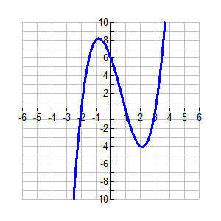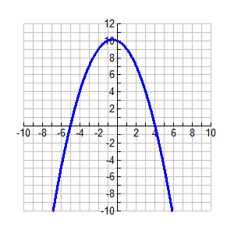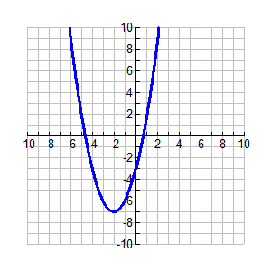24. What is the, , maximum, minimum, domain, and range of each graph below.

a. b. c.

**25**. Simplify the following functions.

a.  b.  c.  d. 

**26**. Describe the transformations of the function from the parent graph of 

a.  b.  c.  d. 

**27**. Describe the end behavior of the following functions

a. f(x) = 4(x + 3)(x – 5) b. f(x) = x2 + 7x + 12 c. f(x) = 3(x – 5)2  + 7

**28.** Find the exact roots of the polynomial.

a.  b.  c.  d. 

e.  f.  g. 

**29.** Write the polynomial equation of least degree for the roots given.

a. 1,0,-5 b. -2,  c. double root at 8, , 0

**30.** Divide.

a.  b. 

**31.** Find the remainder for each division. Is the divisor a factor of the polynomial?

a.  b. 

R Factor? R Factor?

**32.** Find all possible rational zeros of the function. Then determine all the zeros.

a.  b. 

Possible zeros: Possible zeros:

Zeros: Zeros:

**33**. Graph the following functions and find the domain, range, and find the maximum or minimum.

a.  b.  c. 

**34.** Write an equation to the following graph. (Hint: use the x-intercepts to write the equation)



What are the x-intercepts? __________________________

Write your factors of the polynomial by using the x-intercepts. _________________

“FOIL” or Distribute your factors above _______________________________

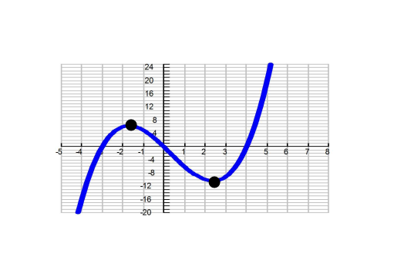**35.** Find the zeros, end behavior, maximum(s), and minimum(s) for each graph below.

a. b. c.





**36.** Find the zeros

a.  b.  c. 

**37.** Graph the following functions and find the vertical asymptote(s), horizontal asymptote(s), and holes.

a.  b. 

**38.** Simplify

$$\frac{3x+12}{3x}∙\frac{x+1}{x^{2}}$$

$$\frac{x^{2}+5x-14}{x-1}÷\frac{x-2}{5}$$

$$\frac{x+5}{3x}÷\frac{x-4}{x}$$

**39.** Solve for the variable. Check your solutions and restrictions.

a. $\frac{2x}{3}+\frac{4x}{9}=\frac{1}{5}$ b. $\frac{x+3}{x+2}+\frac{4x}{x-5}=\frac{7}{x+2}$ c. $\frac{5}{x-2}+\frac{4}{3x}=\frac{1}{3x}$