Graph the Following Piecewise Functions:
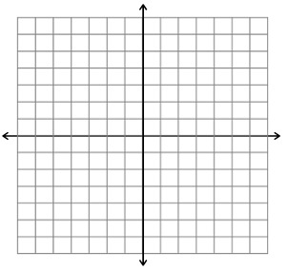
1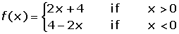 2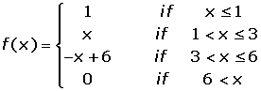

3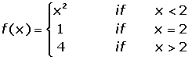 4. Find the analytical expression of the function.
