Name:________________________Date:________________Period:_______________

Similar techniques for solving rational equations can be used to solve rational inequalities. Solutions should be expressed using interval notation and a shaded number line.

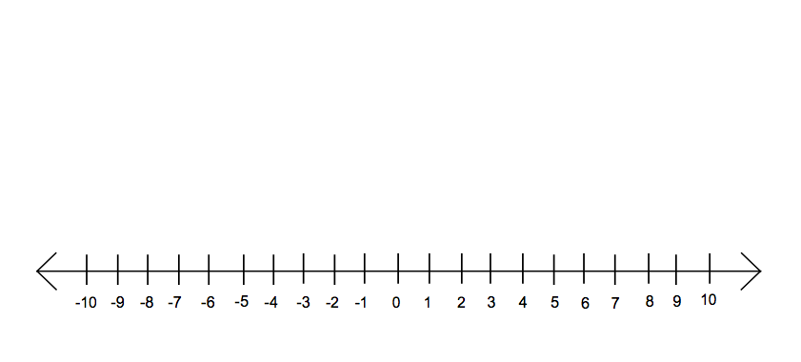
Example: Solve $\frac{2}{3x}+\frac{5}{6x}>\frac{3}{4}$

Steps:
1) Replace the inequality with an equal sign and solve $\frac{2}{3x}+\frac{5}{6x}=\frac{3}{4}$ for x. Using an LCD value of 12x, multiplying each side of the equation by the LCD and solving for x, the solution to the equation is x = 2.

2) Place the solution x = 2 and the restricted domain values from the original inequality (i.e. x = 0) onto a number line. These are the critical points for the solution. Use open circles for domain restrictions and open or closed circles for the equation solution critical points, based on the original inequality symbol.

3) Select test values for x on each side of each critical point (e.g. x = 3, x = 1, x = -1) and test to see if these values satisfy the original inequality. If the value satisfies the inequality, then this value is part of the solution and the region of the number line containing this value should be shaded. If the value does not satisfy the inequality, the region of the number line containing that value should not be shaded.

x = -1 doesn’t satisfy the inequality. x = 1 does satisfy the inequality. x = 3 doesn’t satisfy the inequality

4) Write the shaded solution 0 < x < 2 using interval notation, i.e. (0, 2)

Solve the following rational inequalities. Draw and shade a number line and express the solution using interval notation.

1) $5+\frac{1}{x}>\frac{16}{x}$ Solution:_____________________

2) $1+\frac{5}{x-1}≤\frac{7}{6}$ Solution:_____________________

3) $\frac{(x-2)(x-1)}{\left(x-3\right){\left(x-4\right)}^{2}}<0$ Solution:_____________________

4) $\frac{2}{x}+3>\frac{29}{x}$ Solution:_____________________

5) $\frac{x^{2}-16}{x^{2}-4x-5}≥0$ Solution:_____________________

6) $\frac{7}{x+1}>7$ Solution:_____________________

