Int. Trig Name_____________________________
Test Review (Graphing Rational)
List out the steps to graph and label all the parts.
How to find HA? ________________________ How to find VA? __________________ How to find holes? __________
The calculator helps you graph each functions by ____________________________________________
List out how you use the graphing calculator
1. _________________________________
2._________________________________
3._________________________________
4._________________________________
Steps to Graph:
1. _______________________________________
2._______________________________________
3._______________________________________
4._______________________________________

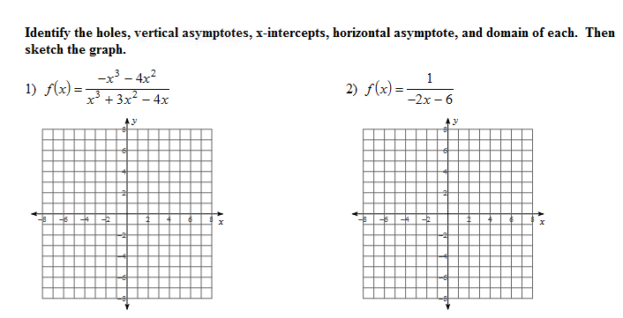

HA ___________________ HA ______________________
VA ___________________ VA ______________________
Holes ________________ Holes ____________________
Domain _______________ Domain __________________
Range ________________ Range ___________________
x-int _________________ x-int____________________

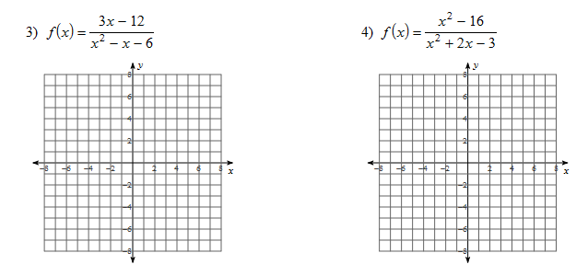

HA ___________________ HA ______________________
VA ___________________ VA ______________________
Holes ________________ Holes ____________________
Domain _______________ Domain __________________
Range ________________ Range ___________________
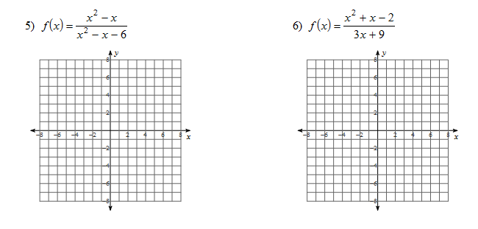
x-int _________________ x-int____________________

HA ___________________ HA ______________________
VA ___________________ VA ______________________
Holes ________________ Holes ____________________
Domain _______________ Domain __________________
Range ________________ Range ___________________
x-int _________________ x-int____________________
