Answer the following concept questions:

How do you find the vertex of a parabola written in standard form? ___________________________________________

What steps are taken to find the vertex, AOS, and all intercepts?_______________________________________

___________________________________________________________________________________________

How do you find the vertex of a parabola written in vertex form? ____________________________________________

What steps are taken to find the vertex, AOS, and all intercepts?______________________________________

_________________________________________________________________________________________________

How do you find the vertex of a parabola written in factored form? __________________________________________

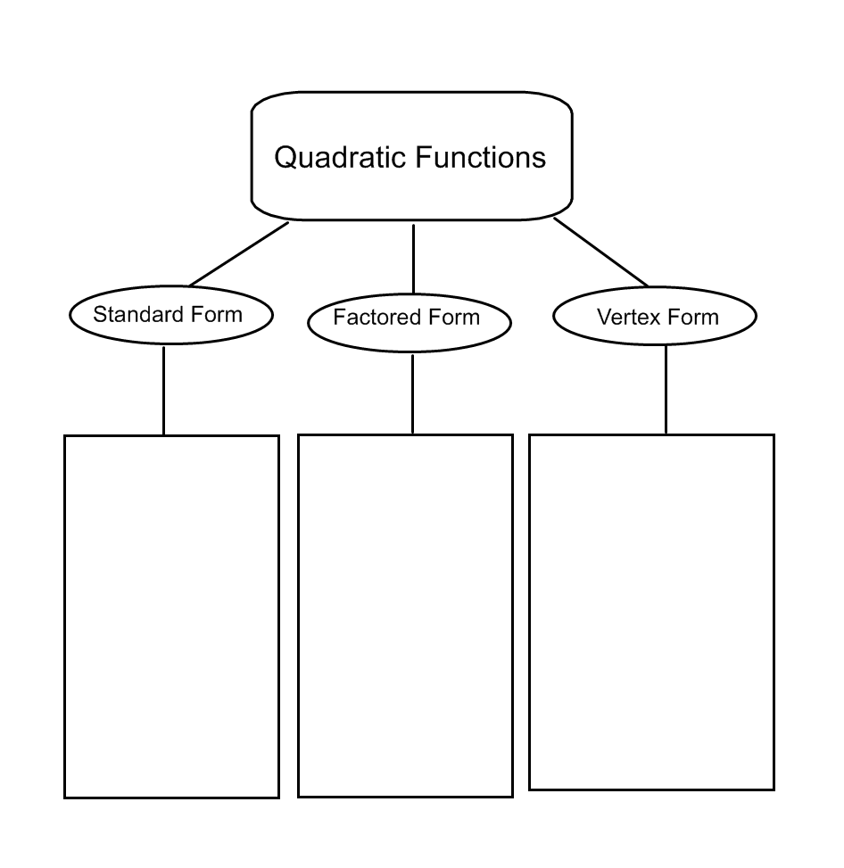 What steps are taken to find the vertex, AOS, and all intercepts?______________________________________

__________________________________________________________________________________________________

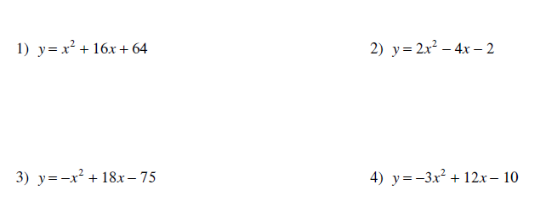**For 1 – 8, (a) Identify the vertex (show work!); (b) Tell whether the graph of the function opens up or opens down; and (c) Give the equation for the AOS (axis of symmetry).**

a. _________________

b _________________

c. _________________

a. _________________

b _________________

c. _________________

a. _________________

b _________________

c. _________________

a. _________________

b _________________

c. _________________

 

a. _________________

b _________________

c. _________________

a. _________________

b _________________

c. _________________

 

a. _________________

b _________________

c. _________________

a. _________________

b _________________

c. _________________

**Graph the following functions and (a) describe if the graph is growth or decay, (b) asymptote line, and (c) one or two points on the graph.**

 

a. _________________

b _________________

c. _________________

a. _________________

b _________________

c. _________________

 

a. _________________

b _________________

c. _________________

a. _________________

b _________________

c. _________________

 

a. _________________

b _________________

c. _________________

a. _________________

b _________________

c. _________________

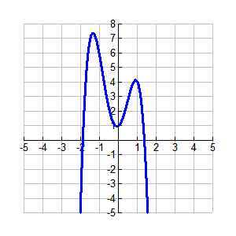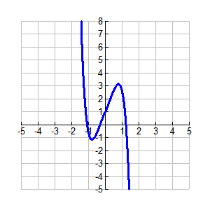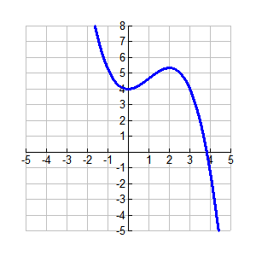Describe the interval of increasing and decreasing on the following graphs.

15) 16) 17)

Increase _________________ Increase _________________ Increase _________________

Decrease ________________ Decrease ________________ Decrease ________________

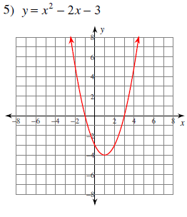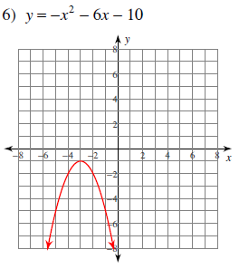**Identify the vertex, AOS, and whether the vertex is a minimum value or a maximum value., then give the value. Also state the domain & range for each.**

Vertex: _______________

Equation of AOS: ________

Min. or Max? ________;

Value: y = ________

Domain: _________;

Range: ___________

Vertex: __________

Equation AOS: __________

Min. or Max? ________;

Value: y = ________

Domain: _________;

Range: ___________