Graph the following functions.
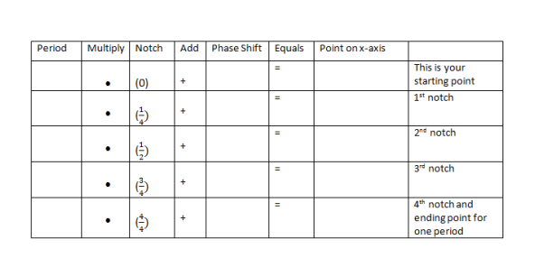
1) $y=4\cos{(θ+\frac{π}{4})}$

2) $y=\frac{3}{5}\sin{(\frac{θ}{4}+2π)}$

3) $y=-2\sin\left(2θ\right)+4$

4) $y=-\cos{(\frac{θ}{2}+π)}$

